Week-7 (DAY-31) Hands-On – Keerthivasan R
Problem 1: Contact Management Web Application (Using Dependency Injection)
Scenario:
ABC Infotech wants to improve their application design by following best practices like Dependency Injection (DI). Instead of handling all logic inside the controller, they want to introduce a service layer to manage contact operations.
The application should still:
- Add contacts
- View all contacts
- Search contact by ID
But now using DI for better architecture.
Requirements:
- Model Class
Create ContactInfo class with auto-implemented properties:
Name | Type | Modifier
ContactId | int | public
FirstName | string | public
LastName | string | public
CompanyName | string | public
EmailId | string | public
MobileNo | long | public
Designation | string | public
2. Create Service Layer (DI Implementation)
Create:
🔸 Interface → IContactService
Include methods:
- List<ContactInfo> GetAllContacts()
- ContactInfo GetContactById(int id)
- void AddContact(ContactInfo contact)
🔸 Implementation → ContactService
- Maintain:
private static List<ContactInfo> contacts = new List<ContactInfo>();
Implement all methods:
- Add contact to list
- Return all contacts
- Search contact by ID
3.Register Service in DI Container
In Program.cs:
builder.Services.AddSingleton<IContactService, ContactService>();
4.Controller: ContactController
Inject service using constructor injection:
5. Action Methods
Function | Description
ShowContacts() | Use _contactService.GetAllContacts() and display list in tabular format
GetContactById(int id) | Use _contactService.GetContactById(id) and display contact
AddContact() | Return view to accept contact details
[HttpPost] AddContact(ContactInfo contactInfo) | Call _contactService.AddContact(contactInfo) and redirect to ShowContacts
6. Startup Configuration
Set default route to:
- Contact → ShowContacts
Technical Constraints
- MUST use:
  - Dependency Injection
  - Interface + Service class
  - Constructor Injection
  - Attribute-based routing (optional but recommended)

- Do NOT use:
  - Database
  - Static List inside Controller ❌
  - Business logic inside Controller ❌
- Static List allowed ONLY inside Service class

Expectations
1. Proper DI implementation
2. Controller should ONLY:
- Receive request
- Call service
- Return response
3. Service should:
- Handle all business logic
- Manage data
4. Clean separation of:
- Controller vs Service
Learning Outcome
After completing this problem, students will:
- Understand Dependency Injection in ASP.NET Core MVC
- Learn:
  - Interface-based design
  - Service layer implementation
  - Constructor injection
- Realize:
  - Why fat controllers are bad
  - How DI improves maintainability & testability

CODE:
Model / ContactInfo.cs
namespace ContactManagementApp.Models
{
public class ContactInfo
{
public int ContactId { get; set; }
public string FirstName { get; set; } = string.Empty;
public string LastName { get; set; } = string.Empty;
public string CompanyName { get; set; } = string.Empty;
public string EmailId { get; set; } = string.Empty;
public long MobileNo { get; set; }
public string Designation { get; set; } = string.Empty;
}
}
Service/ IContactService.cs
using ContactManagementApp.Models;

namespace ContactManagementApp.Services
{
public interface IContactService
{
List<ContactInfo> GetAllContacts();
ContactInfo? GetContactById(int id);
void AddContact(ContactInfo contact);
}
}
Service/ ContactService.cs
using ContactManagementApp.Models;

namespace ContactManagementApp.Services
{
public class ContactService : IContactService
{
// 'static' ensures the data doesn't reset on every page load
private static List<ContactInfo> contacts = new List<ContactInfo>();

public List<ContactInfo> GetAllContacts()
{
return contacts;
}

public ContactInfo? GetContactById(int id)
{
return contacts.FirstOrDefault(c => c.ContactId == id);
}

public void AddContact(ContactInfo contact)
{
// Auto-generate ID if it's 0
if (contact.ContactId == 0)
{
contact.ContactId = contacts.Count > 0 ? contacts.Max(c => c.ContactId) + 1 : 1;
}
contacts.Add(contact);
}
}
}
Controller/ ContactController.cs
using Microsoft.AspNetCore.Mvc;
using ContactManagementApp.Models;
using ContactManagementApp.Services;

namespace ContactManagementApp.Controllers
{
public class ContactController : Controller
{
private readonly IContactService _contactService;

// Constructor Injection
public ContactController(IContactService contactService)
{
_contactService = contactService;
}

// Display all contacts
public IActionResult ShowContacts()
{
var contacts = _contactService.GetAllContacts();
return View(contacts);
}

// Search contact by ID
public IActionResult GetContactById(int id)
{
var contact = _contactService.GetContactById(id);
if (contact == null)
{
ViewBag.Message = "Contact not found!";
return View("ContactNotFound");
}
return View(contact);
}

// GET: Show Add Contact form
public IActionResult AddContact()
{
return View();
}

// POST: Add new contact
[HttpPost]
public IActionResult AddContact(ContactInfo contactInfo)
{
if (ModelState.IsValid)
{
_contactService.AddContact(contactInfo);
return RedirectToAction("ShowContacts");
}
return View(contactInfo);
}
}
} Program.cs
using ContactManagementApp.Services;

var builder = WebApplication.CreateBuilder(args);

// Register the service as a Singleton
builder.Services.AddSingleton<IContactService, ContactService>();

// Add services to the container.
builder.Services.AddControllersWithViews();

var app = builder.Build();

// Configure the HTTP request pipeline.
if (!app.Environment.IsDevelopment())
{
app.UseExceptionHandler("/Home/Error");
// The default HSTS value is 30 days. You may want to change this for production scenarios, see https://aka.ms/aspnetcore-hsts.
app.UseHsts();
}

app.UseHttpsRedirection();
app.UseStaticFiles();

app.UseRouting();
app.UseAuthorization();

app.MapControllerRoute(
name: "default",
pattern: "{controller=Contact}/{action=ShowContacts}/{id?}");

app.Run();
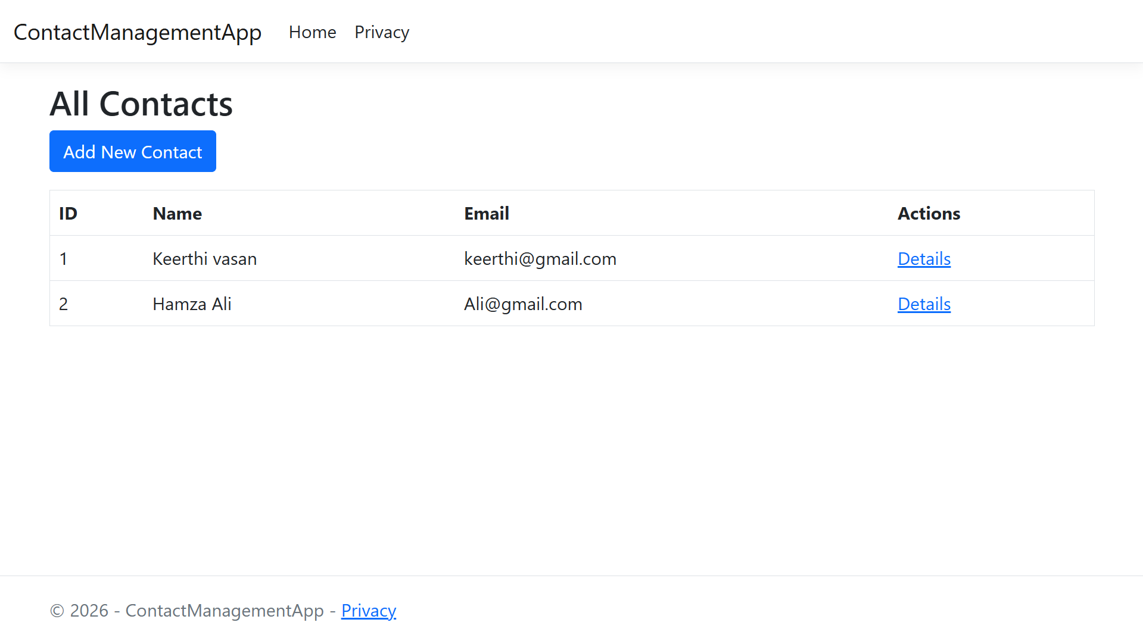
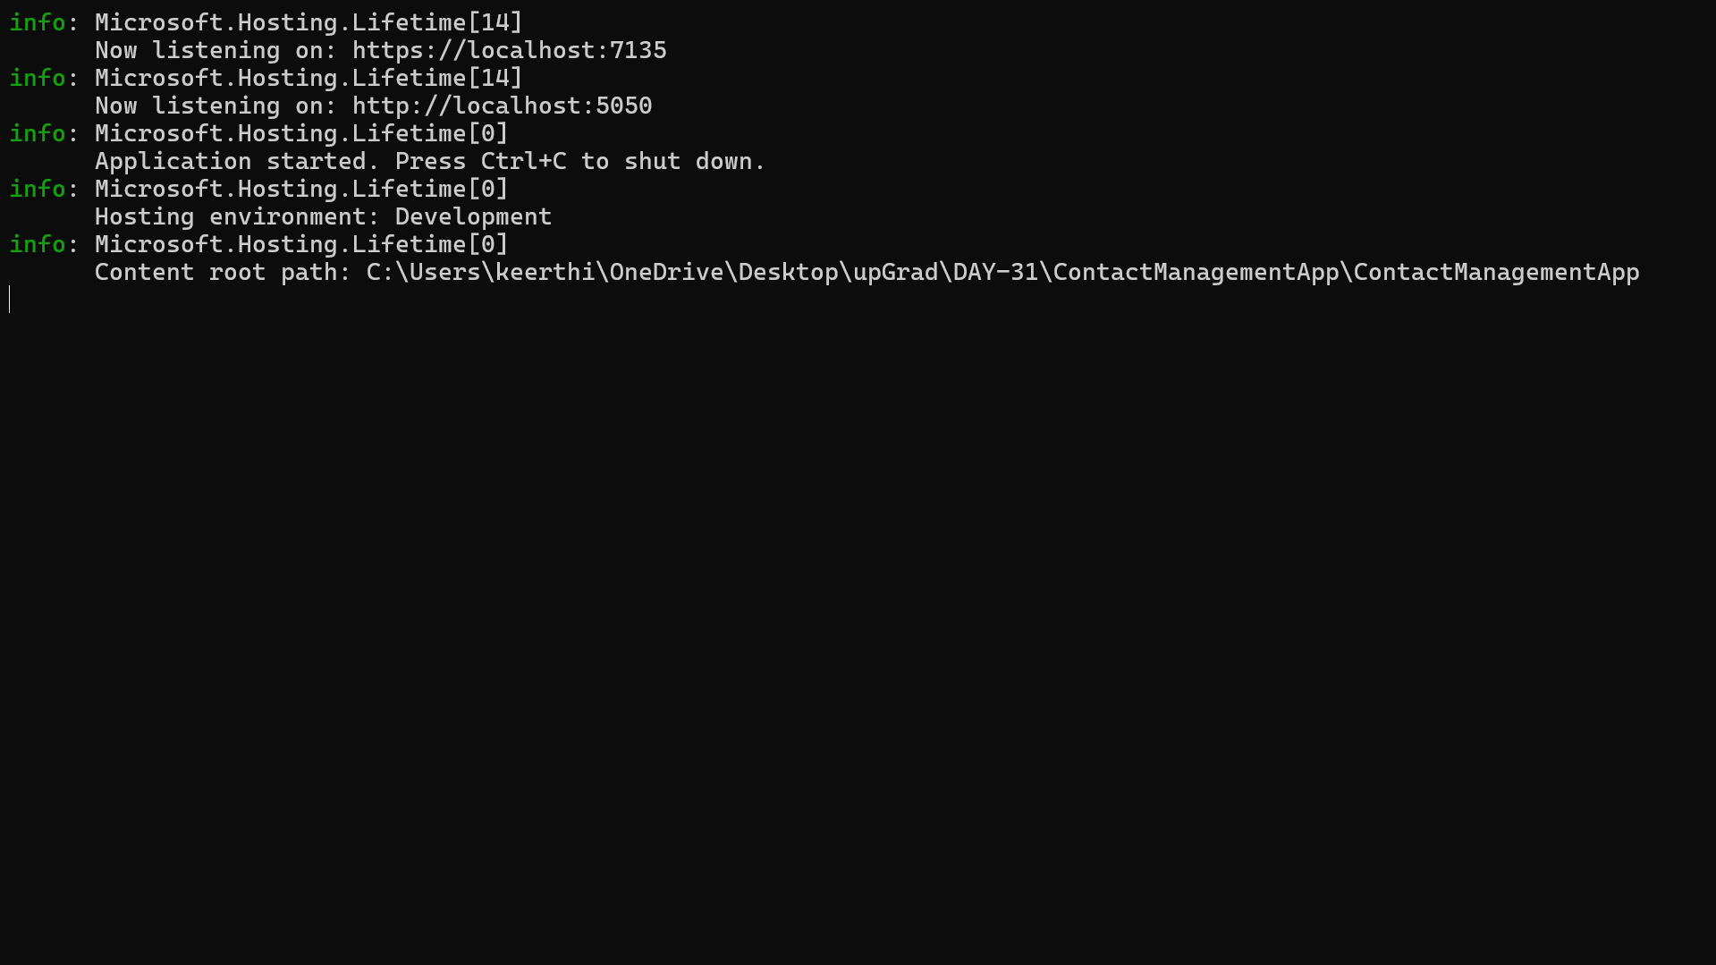
OUTPUT:
